_________________________________
Prayer Request Card

If you would like to share a prayer request, please detach this form and place it in one of the Bread Tins as the children circulate them after the Children’s Celebration.

(Please Print)

Date:__________________

Your Prayer Concern:
_______________________

_______________________

_______________________

Your Name (optional):

_______________________

_______________________

_______________________

☐ Please keep my prayer concern confidential

☐ Please add my prayer concern to the prayer list in the bulletin.

☐ Please remove my concern from the prayer list.

Announcements

*We received $299.96 during the month of December to go towards The United Methodist Church’s Black College Fund. Thanks for your generous support.

In January we will be collecting money to help purchase uniforms for children to go to school in Ghana.

Thanks to all who helped make Room in the Inn possible this past week here at Asbury!
-The Missions Committee

*The staff of Asbury would like to express their kindest regards and appreciation for the generous Christmas gifts we each received this year. Thanks so much!
-Curtis, David, Sallyanne, and Ann.

*The Senior Adult Ministries at Asbury, otherwise known as the “SAMs” group, will meet on Wednesday, January 9th at 11:30 am in the home of Derick and Margaret Tickle [19 Osborne Rd.]. There will be a cottage pie lunch followed by an illustrated talk by Derick on the process of fresco paintings vs. oil paintings. There will also be a short slide show of the theater restoration Derick is currently working on in Illinois. Please let Margaret know if you intend to be there so she will know how big to make the cottage pie! You can call or leave a message at 252-9887 or you may email them at dtickle2@aol.com.

*There will be several meetings this week at Asbury: Worship Committee, Staff Meeting, Long-Range Planning Committee, SAMs Meeting, Trustees, and an Intentional Leadership Development meeting will all be held in the coming week. If you serve on any of these committees, please take note of the time and place. Thank you for your service to our church!

_______________________________________________________________

This Week at Asbury

Today: 9:45 am-Sunday School [Classrooms]
11:00 am-Worship with Communion [Sanctuary]
12:00 pm-“Un-hanging of the Green”
NOW Committee Meeting Cancelled
5:00 pm-Al-Anon [Brown Chapel]
8:00 pm-Alcoholics Anonymous [Fellowship Hall]
Monday 7:00 am-Emmaus Group [Youth Room]
9:00 am-1:00 pm-Church Office Hours
9:00 am-1:00 pm-Preschool [Education Bldg.]
11:00 am-Worship Committee [Brown Chapel]
Tuesday 9:00 am-1:00 pm-Church Office Hours
9:00 am-1:00 pm-Preschool [Education Bldg.]
12:00 pm-Staff Meeting [Givens Estate]
7:00 pm-Long-Range Planning Committee [Choir Room]
Wednesday 9:00 am-11:00 am-Church Office Hours
9:00 am-1:00 pm-Preschool [Education Bldg.]
11:30 am-SAMs Meeting [Derick and Margaret Tickle’s]
7:00 pm-Choir Rehearsal [Choir Room]
8:00 pm-Narcotics Anonymous [Fellowship Hall]
Thursday 9:00 am-1:00 pm-Church Office Hours
9:00 am-1:00 pm-Preschool [Education Bldg.]
6:30 pm-Trustees Meeting [Brown Chapel]
Friday Church Office Closed
9:00 am-1:00 pm-Preschool [Education Bldg.]
8:00 pm-Alcoholics Anonymous [Fellowship Hall]
Saturday Church Office Closed
Sunday 9:45 am-Sunday School [Classrooms]
(1.13.2012) 11:00 am-Worship [Sanctuary]
5:00 pm-Al-Anon [Brown Chapel]
7:00 pm-Intentional Leadership Development [Brown Chapel]
8:00 pm-Alcoholics Anonymous [Fellowship Hall]

_______________________________________________________________

The Ministry of Worship

Pastor.........................................................................The Rev. J. Curtis Goforth
[curtis@asburymethodist.org]

Assistant Pastor..............................................................The Rev. David Warren
[david@asburymethodist.org]

Minister to Youth and Children...............................The Rev. Sallyanne McVay
[sallyanne@asburymethodist.org]

Minister of Music/Accompanist...............................................Mrs. Ann Perkins
[ann@asburymethodist.org]

_______________________________________________________________
______________________________________________________________
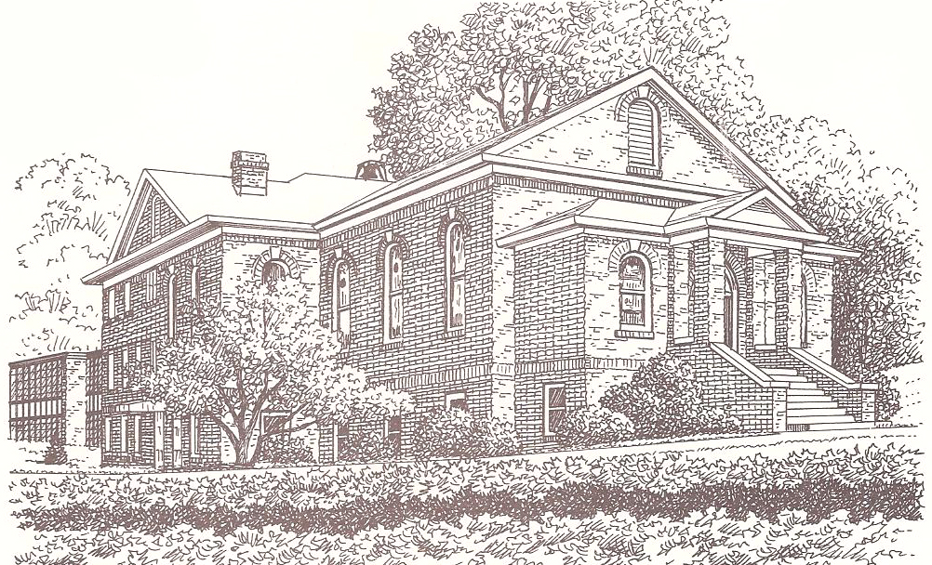
A Service of Worship
Epiphany Sunday-C
January 6, 2013
Asbury Memorial United Methodist Church
www.asburymethodist.org
_______________________________________________________________

If you are visiting with us today, we are glad you are here!
Please take a moment to fill out a visitor’s card
and place it in the offering plate as it circulates.
The congregation reads the words in bold type.

Entrance
Chiming of the Trinity
Prelude................................................................................“The First Noel”
The Light of Christ Enters our Gathering
Choral Introit.................................................“Go, Tell It On the Mountain”
Welcome and Announcements
Hymn #254...................................................................“We Three Kings”
Responsive Reading..............................................................Isaiah 60:1-6

Arise, shine; for your light has come,
and the glory of the LORD has risen upon you.

For darkness shall cover the earth,
and thick darkness the peoples;
but the LORD will arise upon you,
and his glory will appear over you.
Nations shall come to your light,
and kings to the brightness of your dawn.
Lift up your eyes and look around;
they all gather together, they come to you;
your sons shall come from far away,
and your daughters shall be carried on their nurses' arms.
Then you shall see and be radiant;
your heart shall thrill and rejoice,
because the abundance of the sea shall be brought to you,
the wealth of the nations shall come to you.

A multitude of camels shall cover you,

the young camels of Midian and Ephah;
all those from Sheba shall come.

They shall bring gold and frankincense,
and shall proclaim the praise of the LORD.

__________
The congregation standing, if able.
Gloria Patri #70

♫ Glory be to the Father, and to the Son,
and to the Holy Ghost. As it was in the beginning,
is now and ever shall be; world without end.
Amen. Amen. ♫

Proclamation and Response
Children’s Celebration
Collection of our Bread Tin Offering and Prayer Cards

* The January bread tin collections will go to the purchase of school uniforms for needy children in Ghana. You may place your gift in one of the bread tins as the children circulate them. Those who are of kindergarten age and younger are invited to leave for children's church in the chapel, or to remain in the service with their families.

**You may also place a prayer card in one of the bread tins
if you have a special prayer request you’d like to share.

Prayer for Illumination

Holy Father, Creator of the heavens,
who led the magi by a star to worship the Christ Child: lead us today as we hear your word;
guide and sustain us, that we may find our journey’s end in Jesus Christ our Lord. Amen.

Gospel Lesson.............................Matthew 2:1-12 (NT p.1 in the pew Bible)

¹In the time of King Herod, after Jesus was born in Bethlehem of Judea, wise men from the East came to Jerusalem, ²asking, "Where is the child who has been born king of the Jews? For we observed his star at its rising, and have come to pay him homage." ³When King Herod heard this, he was frightened, and all Jerusalem with him; ⁴and calling together all the chief priests and scribes of the people, he inquired of them where the Messiah was to be born. ⁵They told him, "In Bethlehem of Judea; for so it has been written by the prophet:
⁶'And you, Bethlehem, in the land of Judah, are by no means least among the rulers of Judah; for from you shall come a ruler who is to shepherd my people Israel.'"
⁷Then Herod secretly called for the wise men and learned from them the exact time when the star had appeared. ⁸Then he sent them to Bethlehem, saying, "Go and search diligently for the child; and when you have found him, bring me word so that I may also go and pay him homage." ⁹When they had heard the king, they set out; and there, ahead of them, went the star that they had seen at its rising, until it stopped over the place where the child was. ¹⁰When they saw that the star had stopped, they were overwhelmed with joy. ¹¹On entering the house, they saw the child with Mary his mother; and they knelt down and paid him homage. Then, opening their treasure chests, they offered him gifts of gold, frankincense, and myrrh. ¹²And having been warned in a dream not to return to Herod, they left for their own country by another road.

The Word of the Lord.
Thanks be to God.

Sermon..............“The Gifts of the Magi”............The Rev. J. Curtis Goforth

Holy Communion

The sacrament of communion is open to ALL who wish to receive.

Prayers of the People
Silent Prayers

...Lord, in your mercy,
hear our prayer.

Offering
Offertory Anthem.........................................................“Communion Carol”
Doxology #95

♫ Praise God from whom all blessings flow.
Praise him all creatures here below.
Praise him above ye heavenly host.
Praise Father, Son, and Holy Ghost. Amen. ♫

Offertory Prayer
The Great Thanksgiving p.20 [hymnal]

We will be following Musical Setting C this morning for our communion liturgy.
The choir and congregation sing the responses.

The Lord’s Prayer

...And now, with the confidence of the children of God, we are bold to pray as our Lord taught us, saying:

Our Father, who art in heaven, hallowed be thy name.
Thy kingdom come, thy will be done on earth as it is in heaven. Give us this day our daily bread. And forgive us our trespasses, as we forgive those who trespass against us.
And lead us not into temptation, but deliver us from evil.
For thine is the kingdom, and the power, and the glory, forever. Amen.

The ushers will assist you with the appropriate time to come forward.
If you are unable to come forward to receive communion,
please notify an usher so that you may be served in your seat.

Sending Forth
Hymn #224..........................................“Good Christian Friends, Rejoice”
Benediction....................................................The Rev. Sallyanne McVay
Choral Benediction.....................................................“Three-fold Amen”
The Light of Christ Leads Us into the World
Postlude..........................................................................“Allegro Vivace”

__________
The congregation standing, if able.
_________________________________

Asbury Memorial
United Methodist Church
Visitor’s Card

We are grateful for the opportunity to contact you to let you know how glad we are that you visited! Your information will be kept private.

Please take a moment to fill out this card. It can be detached and placed in the offering plate as it circulates later in the service.

(please print)

Date:________________

Name(s):_____________

____________________

____________________

Street Address:_____________

____________________

City:________________

State:______Zip:______

Phone: ( ) ____________________

Email Address:

____________________

____________________

Comments:
____________________

____________________

____________________

____________________

____________________

____________________

Prayer List

The prayer list is started over on the first of each month. If you have a new prayer request, or if you would like one added this month, please fill out a prayer request card and place it in one of the Bread Tins as the children circulate them after the Children’s Celebration. Thanks for your understanding.

Bill McGeary (Donnie McGeary’s brother with cancer), Bruce McIntosh (Don McGeary’s brother-in-law with heart trouble), Addison McGeary, Steve Ellis, Sue Muser (friend of Lee Kucera), Marlys Berg (friend of Larry and Janie Wilson), Gary Hutchins, the ladies from Room in the Inn, Kathy Morgan (Marcia Morehead’s sister), our shut-ins.

Volunteer Schedule
January 6, 2013

Counting Team | Merritt Moseley  Sue Lane Muesing
Lock-up Volunteer | William Withers
Greeters | Cynthia Stewart  John Stewart
Sanctuary Stewards | Cathy Mills  Madeline Moseley
Nursery Volunteers | Don Jackson  Davie Jackson
Children’s Church | Margaret Tickle
Children’s Sermon | Margaret Tickle
Acolyte | Mitchell Tucker
Communion Servers | Gordon Jones  Elaine Poovey

Volunteer Schedule
January 13, 2013

Counting Team | Geri Allison  Rebecca Tucker
Lock-up Volunteer | William Withers
Greeters | Geri Allison  Jessica Withers
Sanctuary Stewards | Steve Rich  Judy Rich
Nursery Volunteers | Cathy Mills  Judy Rich
Children’s Church | Heather Post
Children’s Sermon | Curtis Goforth
Acolyte | Cora Goforth

